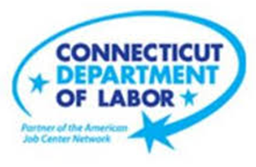

**NEW WEEKLY JOB POSTINGS FROM   
HELP WANTED ONLINE  
Office of Research**

**Week Ending July 2nd, 2022:   
Transportation & Warehousing, Retail, and Information Drive Over The Week Increase**WETHERSFIELD, July 8th, 2022 – During the week ending July 2nd, there were 9,272 new postings, up 579 new ads or +7% over the week. The graph below illustrates the large week-to-week swings present at the U.S. and state level. Connecticut’s over the week 7% increase is driven by increases Transportation & Warehousing, Retail Trade, and Information. Employers with large over the week increases include Masonicare, The Home Depot, and FedEx. Occupations with the largest over the week increases include Heavy & Tractor Trailer Truck Drivers (+201 new ads), Retail Salespersons (+146 new ads), and Licensed Practical & Licensed Vocational Nurses (+105 new ads). The most recent weekly new ads total down 7% from a year ago, the first week ending in July 2021 was one of the highest weekly counts of 2021.   
  
  
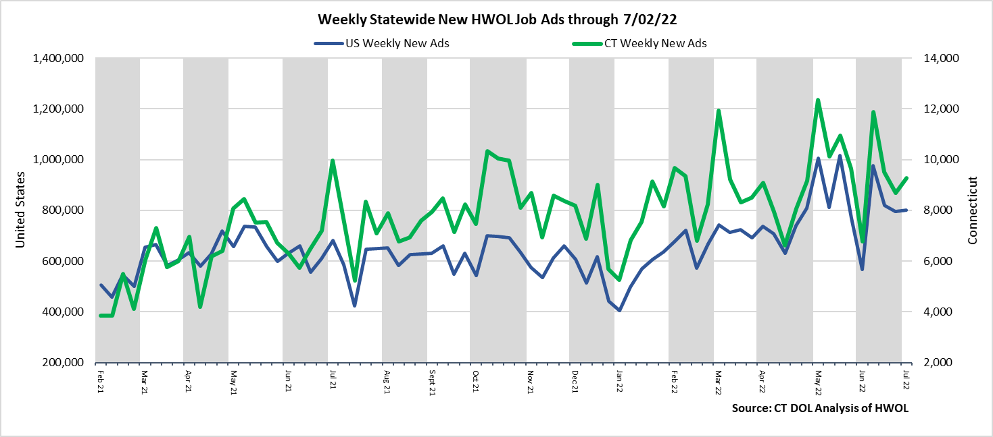  
**Industries** with the most new postings include Health Care & Social Assistance, Retail Trade, and Finance & Insurance.

**Occupations** with the most new postings include Registered Nurses, Retail Salespersons, Heavy & Tractor Trailer Truck Drivers.

**Employers** with the most new postings include Masonicare Corp., Capital One, and The Home Depot.

**The three industries with the most new job postings were:**

* **Health Care & Social Assistance** (1,705 new postings, -10% over the week)
* **Retail Trade** (1,025 new postings, +27% over the week)
* **Finance & Insurance** (1,023 new postings, +2% over the week)

  
 During the week ending July 2nd, 2022, the total ad increase of 579 new ads or +7% is the net result of increases in 12 of 21 industries. These 12 industries were up a combined 985 new ads, with the largest gains occurred in Transportation & Warehousing (+355 new ads), Retail Trade (+218 new ads), and Information (+103 new ads). The 6 declining industries fell by a combined 406 new ads, with the largest drop occurring in Health Care & Social Assistance (-181 new ads) and Pro., Sci., & Tech. Services (-91 new ads). Over four weeks, the total increase of 2,425 new ads is the result of gains in all but 2 industries. More than half of the four-week increase occurred in four industries, Retail Trade (+377 new ads), Health Care & Social Assistance (+369 new ads), Finance & Insurance (+332 new ads), and Transportation & Warehousing (+279 new ads).   
  
 For more information on total job ads by industry for Connecticut and its labor market areas, see the monthly report available here: <https://www1.ctdol.state.ct.us/lmi/hwol.asp>

**New Job Postings by Occupation** 

**The occupations with the most new postings were:**

* Registered Nurses (447 new postings, -10% over the week)
* Retail Salespersons (363 new postings, +67% over the week)
* Heavy and Tractor-Trailer Truck Drivers (297 new postings, +209% over the week)

**Employers with the Most New Job Postings**

Employers with the most new job postings during the week were mostly in Health Care, Retail Trade, and Finance & Insurance. The 25 employers shown above account for 20 percent of all new ads. 15 of 25 employers in the top 25 had over the week increases, 1 was unchanged, and 9 declined. Over four weeks, 22 employers in the top 25 had increases, one was unchanged, and 2 had decreases. The employer with the largest increase over both one and four weeks was Masonicare Corp., up 201 new ads over the week and up 203 over four weeks. The top-25 employer with the largest over the week decrease was Community Health Center, down 211 new ads from a week ago.  
  
**What is HWOL?**The **Conference Board Help Wanted Online**® Data Series (HWOL) measures the number of new, first-time Online job postings and jobs reposted from the previous month for over 16,000 Internet job boards, corporate boards and smaller job sites that serve niche markets and smaller geographic areas. To view more HWOL data, go to: <https://www1.ctdol.state.ct.us/lmi/hwol.asp>